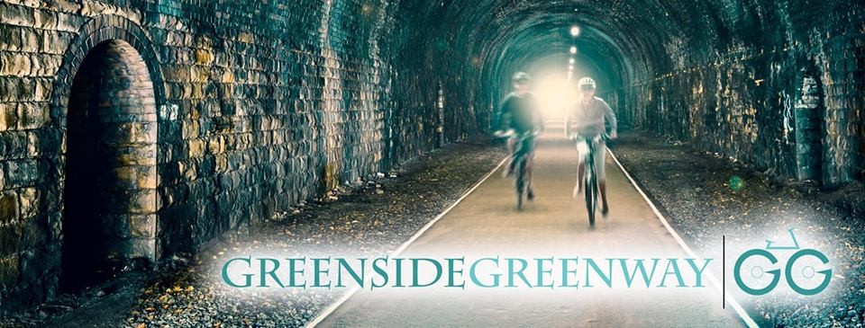CAMPAIGN UPDATE

We have campaigned and organised on several different fronts as we strive to make Greenside Greenway a reality. Here is an overview of our activities since March 2020, despite Covid.

OUR OBJECTIVES

To fund a feasibility study into the costs and practicalities of the construction of a greenway path, available for cyclists and walkers through the Greenside Tunnel. If feasible, in terms of costs and funding, to secure the eventual construction of the Greenway

To secure the eventual linkage of the Greenway to the Leeds Cycleway at Stanningley, and to the Spen Valley Greenway at Oakenshaw, by constructing a Greenway linking through Tyersal, Holmewood and Low Moor railway station.

To liaise with and lobby all relevant organisations who can help and assist with the eventual construction of the Greenway.

Two of our main objectives are now complete. We have fundraised (£10,000), and now have a completed study from Sustrans for Phase 1 (Greenside tunnel to Tyersal).

ENVIRONMENTAL CAMPAIGNING ACTIVITIES

We have arranged litter picks of the route and held our first guided walk of phases 1 & 2 where we had 25 residents attending. We have produced a self-guided route plan/map and also intend to produce an informative map/guide of the route with an offer of assistance by a local illustrator.
Footpath claims We are currently on with submitting claim to Leeds Parks and Countryside Public Rights of Way (PROW|) for two sections of unofficial footpaths, Mount Pleasant Road to Lowtown and Tyersal embankment the former one which is owed by the Ogden Group,
Problems with illegal bikes, we have posted notices to report illegal off-roading such as quad and motor bikes in Black Carr woods/Fulneck and on the embankment. We have also liaised with West Yorkshire Police on this.
Historical Railways Estate (Highways England), (owner of the Tunnel) We reported on many occasions the insecure gates, and requested then to fit more secure locks. Works are now completed to prevent anti-social activities /adverse publicity and issues with disturbing bat habits.
FUTURE FUNDRAISING ACTIVITIES
Social events. Due to Covid we had to cancel our planned ‘Light at the end of the Tunnel’ music evening at the Royal for which we had four local bands lined up. We are in the process of re arranging this.
Heritage Display boards for Lowtown and Greenside rail stations We are in process of finalising content for proposed new heritage display stands, which we have identified sites for near the former rail station sites and if enough funding raised to provide a bench seat at each site. We need to have a bespoke fundraising effort to raise funds for this project.
Applications for fundraising. Over the last 12 months we have made applications to City Connect, and local charities. We have also approached Sustrans to consider funding a feasibility study for phases 2/3 So far with no success. We hope that our pending charitable status will open up other new funding opportunities.

PLANNING ITEMS
We have objected to the extra two dwellings built (retrospective planning application in 2021) by EP homes which are on part of the infill of the rail cutting, made in 2020 after full infilling of the cutting was refused in 2019. This now prevents a possible access point to the Greenway track.
We also complained about the additional land fill, and that no seeding has taken place which was one of the conditions made when the partial infill was granted in 2017.
We have commented on a planning application on phase 2 of the route near Varleys Yard/Kent Road housing development and requested 3 metres of additional land next to the current top footpath.
ORGANISATIONAL ACTIVITIES
Progressing the Feasibility Study. We have had a meeting with the Combined Authority (CA)/Leeds City Council , we need to get the route on the next batch of Walking and Cycling Infrastructure plans. There is a hold up as the future plans for Rapid Transport for West Yorkshire (RTWY) have not discounted using the Greenside Greenway route. Spen Valley Greenway is also a suggested RTWY route.
Phase 2/3 Stanningley to Mount Pleasant Road - Carlisle Road. At the same meeting as above, it was suggested we initially consider progressing these phases first as most of route already has access, not as expensive and minimal land issues. We will need funds for a feasibility study to progress this.
Bradford MDC have indicated on their Walking and Cycling plans and proposed housing development for South Bradford) a new Greenway link in the Tyersal /embankment area and improved links to the Spen Valley Greenway. This would become phase 4 of our Greenway plans.
Other Organisations, we are members of Leeds Parks and Countryside Forum, there are over 90 local groups within Leeds. We also keep in touch with other Greenway groups such as Elmet and Queensbury, Leeds Ramblers Association .and other local groups such as Save Tong Valley, Pudsey and District Civic Society.

Walking and Cycling works in Pudsey, as part of the £750,000 (cancelled Leeds trolley bus /tram compensation government funding) This project is to make links to New Pudsey rail station easier for residents and encourage more waling and cycling and is nearly complete now. We took part in a planning meeting, and asked for signage to be included as part of the phase 2/3 of the Greenway area, also to review the Richardshaw Lane cycling /walking provision with new and pedestrian lights needed over the Stanningley-by pass. No reply as yet.
Local Media promoting the Greenway. We had a good 2-page overview on the completed feasibility study thanks to the Pudsey Squeaker. Also many thanks a to West Leeds Dispatch for excellent articles on our plans.
We operate and maintain a web site greensidegreenway.org have a Facebook page: Greenside Greenway and our Twitter account is at: @greensidegreen. We provide posters advertising campaigns at sites in Pudsey and the Pudsey Community Hub.

Charity Status, we have now completed the application process to the Charity Commission and our application is pending.
The constitution of the group is due to be changed to comply with requirements for our application for Charitable status.
Membership for supporters of Greenside Greenway group is free and we have over 60 supporters.
Committee meetings are held monthly at the Royal Hotel and we have an active committee working on different issues.
The current committee is made up from people local to Pudsey: Chair: Andrew Jarosz, Vice Chair: Gary Lemal, Secretary Martin Stanley Treasurer /Publicity David Dowden, . Membership Secretary: Andy Wilson, Other committee members are: Lee Carter, Chris Dunford-Kelk, George Dyker, Denise Hanson, Judy Wardle Charlotte Hobson,

November 2021

